A000-Afr-Ghana-Kumasi-Ashante-Akan-Ancestoral Bust —20th Century   
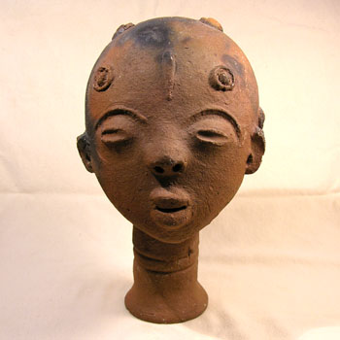

Fig. 1. Afr-Ghana-Kumasi-Ashante-Akan-Ancestoral Bust —20th Century

**Case No.:6**

**Accession No.**

**Formal Label:** Afr-Ghana-Kumasi-Ashante-Akan-Ancestoral Bust —20th Century

**Display Description:**

Fine Akan terracotta ancestral head. These well executed heads served as stylized funerary portraits and memorials for the Akan peoples of Ghana. In excellent condition with only minor chips missing from the ears. Reddish clay with some darker areas known as "fire clouding", a result of uneven temperatures in the wood-fired kilns.

**LC Classification:**

**Date or Time Horizon:**

**Geographical Area: Kumasi, Ghana**

**Map:**

**GPS coordinates:**

**Cultural Affiliation: Ashante**

**Media: terra cotta**

**Dimensions: H** 9 in x W x 5.5 in

**Weight:**

**Condition:**

**Provenance:**

**Discussion:**

**References:**